Redhill Primary Academy

SEND Information Report

June 2026

Redhill Primary Academy is a mainstream Academy with pupils ranging from 4-11 years old. We have an onsite nursery provision catering for children from rising 3 to 5 years of age.
Our Aim

At Redhill Primary Academy, we believe every child has unique needs and that our entire Academy is enriched because of this. We aim to enable all children to achieve their potential and plan very carefully to support and challenge them to do so.

Our Objectives

To identify, at the earliest possible opportunity, barriers to learning and participation for pupils with SEND:

- To ensure that every child experiences success in their learning and achieves to their highest possible standard.

- To enable all children to participate in lessons fully and effectively.

- To value and encourage the contribution of all children to the life of the Academy.

- To work in partnership with parents.

- To work closely with external support agencies, where appropriate, to support the need of individual pupils.

- To ensure that all staff have access to training and advice to support quality teaching and learning for all pupils.

What kinds of special educational needs are provided for at Redhill?

We recognise that children may have needs in one or more of the following areas:

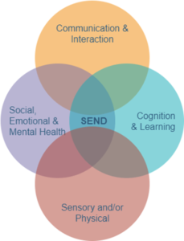
• Cognition and Learning – This includes children who may find learning more difficult than others of the same age, including those with moderate, severe or specific learning difficulties such as dyslexia or dyscalculia. Support is carefully tailored through differentiated teaching, scaffolding strategies, and, where appropriate, targeted interventions to help pupils make progress in their learning.

• Communication and Interaction – Some children may experience difficulties with speech, language or communication, including those with Autism Spectrum Condition (ASC). At Redhill Primary Academy, we support pupils in developing their communication skills through structured approaches, visual support systems, and opportunities for meaningful interaction within a supportive and understanding environment.

• Physical and Sensory Needs – We support pupils who may have physical disabilities or sensory impairments, such as hearing or visual difficulties. Our school environment and teaching practices are adapted where necessary to ensure accessibility, independence and full participation in all aspects of school life, working closely with external professionals when required.

• Social, Emotional and Mental Health (SEMH) – Some children may experience challenges with emotional regulation, behaviour, anxiety or mental health. We are committed to promoting positive wellbeing through a caring and consistent approach, providing pastoral support, clear routines, and interventions that help children develop resilience, confidence and positive relationships.

At Redhill Primary Academy, we take a whole-school approach to inclusion, working in partnership with families, staff and external agencies to ensure that every child feels safe, supported and able to succeed.

How do we identify and assess pupils with special educational needs?

Children with SEND are identified by one of three assessment routes, all of which are part of the overall approach to monitoring progress of all pupils.

• Tracking individual progress over time.
• Information from previous schools/settings on transfer.
• Use of the local authority SEN criteria.
• Following up parental concerns.
• Information from other services.

The progress of every child is monitored at termly pupil progress meetings. Where children are identified as not making progress in spite of Quality First Teaching, they are discussed with the team leader, SENCO and head of school and a plan of action is agreed.

At the Academy, we make regular assessments of children and record their progress against the statutory requirements of the Early Years Foundation Stage in nursery and reception and against the National Curriculum for children from Years 1 to 6. We also monitor closely children’s emotional and social wellbeing.
Parents sometimes ask us to look more closely at their children’s learning. We take parental requests seriously and investigate them all. If you feel that your child has any special educational needs, please contact our SENDCo, Miss Harrow, who will be pleased to discuss your concerns in detail with you.


Sometimes, a child may have been identified as having a Special Educational Need or Disability before starting school. Where this is the case, we work closely with parents and external agencies to ensure a smooth transition into the Academy and plan how we will meet their need.

Where assessments and observations show a child is not working at age related expectations, or they are making less than expected progress, or if they are finding it difficult to make friends, behave appropriately, or are showing some other social and/or emotional difficulties, we will use our professional judgement to ascertain if the child may have a special educational need. The child will then receive an individual learning plan (ILP) to track and monitor the additional provision I place.

How do we meet the needs of children with SEND?
In accordance with the SEND Code of Practice 2015, we adopt a graduated response to SEND provision determined by the support each individual child requires. We use a three-tier approach to classify educational needs that are additional to, or different from everyday classroom provision.

Universal/Wave 1 – This type of support will happen in the classroom. Teachers will focus on a particular child or group of children in order to achieve specific targets.

Targeted/Wave 2 – This type of support will happen in additional to lessons taught in class. This is support for children who need a little extra help to access the curriculum fully. These will be short term interventions.

Specialist/Wave 3 – This is additional support for those children who despite wave 2 intervention require further support or those children who have specific needs that require a greater level of support. This can be 1:1 support based on an individual programme developed for that child to achieve adapted and focused targets. These targets will sometimes be set with support from external agencies.

We believe that all children learn best with the rest of their class. Our aim is for all children to be working independently, in class, at the cusp of their potential. All children are taught by their teacher. We aim to provide additional support to enable the child to reach their full potential, with appropriate challenge, with opportunities for independence.

When considering any adaptions or intervention, we look first at the child’s profile of learning in order that we can select the intervention which is best matched to the child. Targets for children with SEND are appropriately challenging in the attempt to close the attainment gap between the children and their peers.

For an overview of our range of interventions please follow the link below. Please note that this is not an exhaustive list as where appropriate, our provision/interventions are bespoke and tailored to a child’s specific needs as we recognise that one size does not fit all.

http://redhill.ttsonline.net/page/send-documents.aspx

What adaptations are made to the curriculum for children with SEND?

All staff make constant adaptations so that all children can access learning. These adaptations can include the following:

- Breaking curriculum content down into small, achievable chunks
- Use of assistive technology e.g. voice records, applications like Clicker
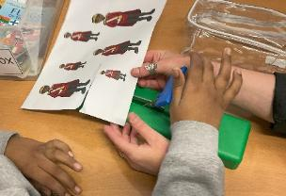
- Providing visual cues and timetables so that children are able to be independent in their learning
- Adding visual supports to that content is understood
- Using timed activities with more extrinsic reward time
- Providing children with resources that allow independent access to curriculum content such as wobble cushions, adapted scissors, ruler and pencils etc.
- Reduced demands on a certain part of the lesson e.g. writing element removed from history lesson

Some pupils receive their teaching in a low arousal space with additional support, resources and learning methods to ensure they have opportunities to progress. This academic year, we have embedded the use of Widget across all of our classrooms and Academy, to support pupils with their understanding of vocabulary and emotional regulation.
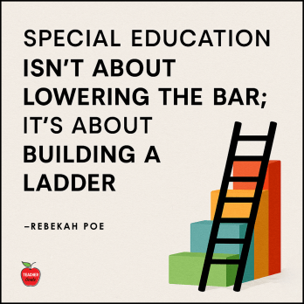

Use of Widgets across school

Visual timetables
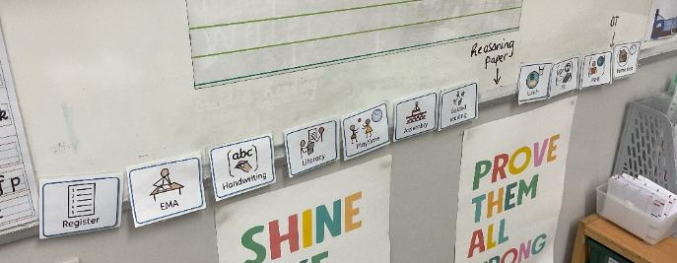

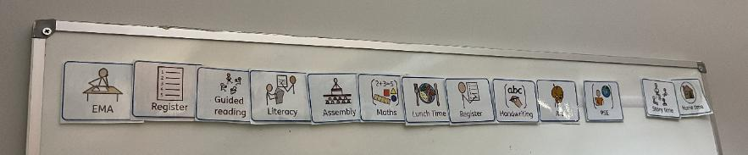

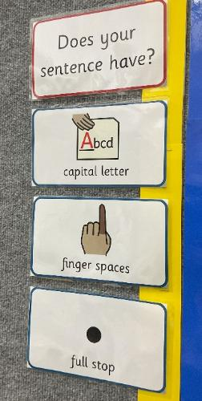
Learning prompts

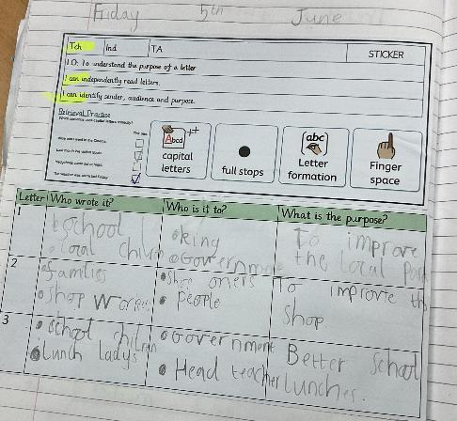

Classroom displays
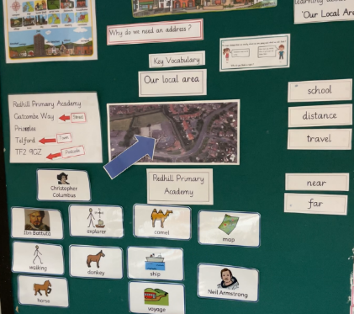
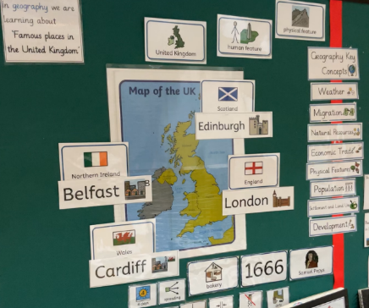

We are committed to supporting pupils with Social, Emotional and Mental Health (SEMH) needs through a consistent, nurturing and child-centred approach. We use restorative conversations to help pupils reflect on their behaviour, understand the impact of their actions, and rebuild relationships in a positive and supportive way. Our dedicated pastoral provision, including ELSA (Emotional Literacy Support Assistant), provides targeted interventions to support emotional regulation, resilience and wellbeing. Within classrooms and wider school environments, we offer adaptable workstations and low-arousal booths to create calm, safe spaces where pupils can focus, regulate or take time out when needed. In addition, we use the Zones of Regulation framework to help children develop a shared language for emotions, enabling them to recognise, understand and manage their feelings more effectively. Through these strategies, we aim to build confidence, independence and positive engagement in learning.
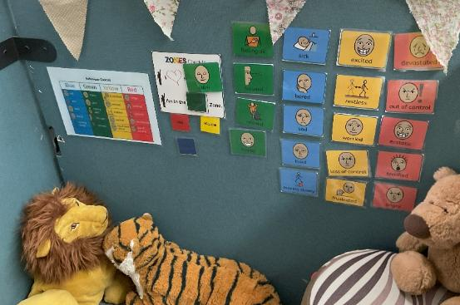
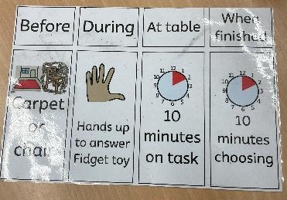

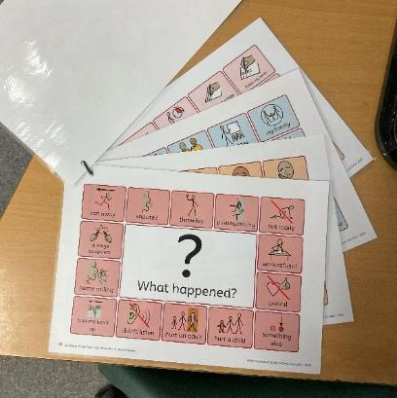

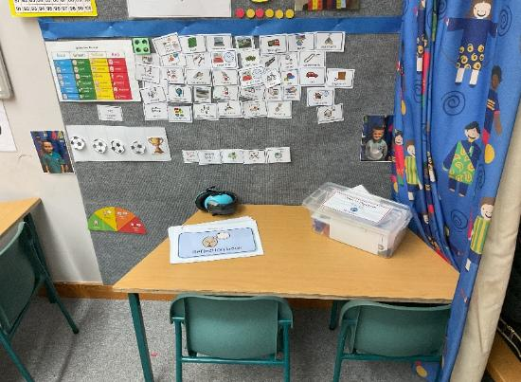

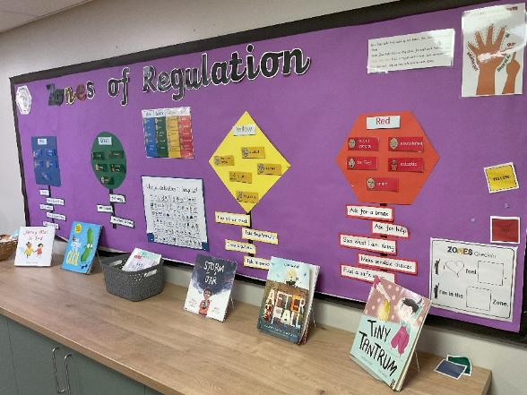

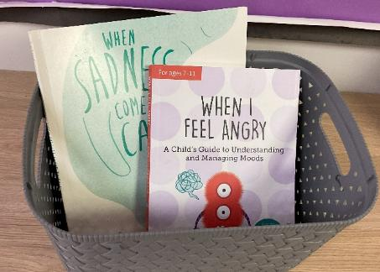

We support pupils with cognition and learning needs through a highly structured, visual and personalised approach to teaching. Strategies such as the TEACCH-inspired work/reward system are used to promote independence and motivation, enabling pupils to clearly understand expectations and experience a sense of achievement. Learning is carefully adapted to meet individual needs through scaffolding, chunking of tasks and the use of colourful semantics to support language development, comprehension and sentence structure. Visual resources are embedded across the curriculum, including now/next boards, visual timetables and prompts, helping pupils to process information and manage transitions with confidence. Consistent morning routines provide a clear and predictable start to the day, supporting pupils to feel secure, settled and ready to learn. Through these approaches, we create an environment where children can access learning at their level, build confidence and develop essential cognitive skills.

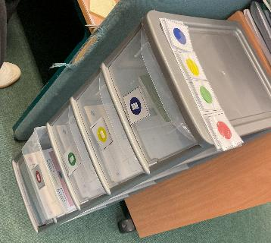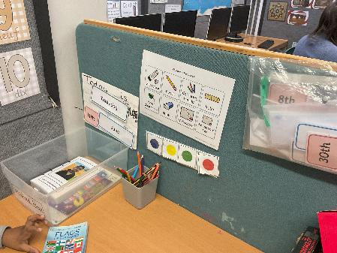

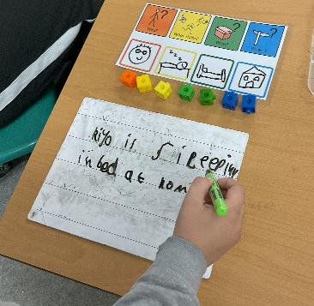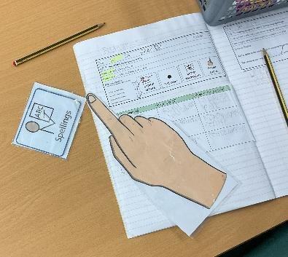

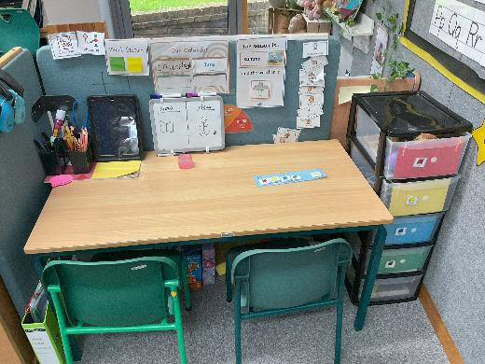

How are parents/carers consulted and involved in their child’s education?

We endeavour to involve parents and carers in all aspects of their child’s education, recognising the importance of strong partnerships in supporting pupil progress. Collaborative planning and target-setting systems for SEND pupils ensure that parents/carers are actively included in reviewing and supporting their child’s Individual Learning Plan (ILP). These are shared and discussed during regular parent consultations, where parents are encouraged to contribute their views, share insights and help shape next steps for learning. In addition, parents/carers are supported through meetings with external professionals, such as speech and language therapists and educational psychologists, ensuring a joined-up approach to provision. The Academy hosts regular consultation meetings throughout the year and invites families into school for open mornings and opportunities to work alongside their child. Our staff are approachable and always willing to support, with informal discussions welcomed whenever parents/carers have questions, concerns or updates to share.

How do we listen to the children’s views?

We value and celebrate each child’s views on all aspects of academy life. This is carried out through our active pupil voice groups, where we ensure pupils with SEND have representation in each group. We also regularly ask the children to complete questionnaires in which they give their views on a number of school issues. Children with individual learning plans discuss their targets with their class teacher and are involved in drawing up the plans. If your child has Education Health Care Plan, their views will also be formally sought at their annual review. We consider individual SENs when deciding how best to capture their views in a meaningful way.

What specialist services and expertise are available or accessed by the Academy?

Staff training needs are continually identified and carefully planned in response to the needs of our pupils, as well as our anticipatory duty to provide inclusive practice. All staff receive regular and ongoing professional development, ensuring they are equipped with the knowledge and skills to support a wide range of SEND needs effectively. This includes whole-school CPD led by the SENCo, alongside specialist training delivered by external agencies such as speech and language therapists, educational psychologists and other professionals. Training over the last academic year has focused on areas such as communication and interaction strategies, adaptive teaching, SEMH support and the use of specific interventions and frameworks within the classroom. All staff also undertake an induction programme upon appointment, which includes a meeting with the SENCo to ensure a clear understanding of the systems, expectations and structures that underpin the Academy’s SEND provision. This ongoing programme of CPD ensures that staff remain confident, reflective and responsive to the evolving needs of our pupils.

Examples of CPD undertaken over the last academic year include:

- Training on adaptive teaching strategies to support pupils with a range of SEND needs
- Zones of Regulation whole-school training to support emotional regulation
- ELSA (Emotional Literacy Support Assistant) supervision and development sessions
- Speech and Language strategies, delivery of TalkBoost intervention, including use of visual supports and communication-friendly classrooms with support from the ELSEC team
- Autism awareness and inclusive classroom practice from Educational Psychologist (e.g. TEACCH approaches, structured environments)
- Use of now/next boards, visual timetables and scaffolding techniques
- Behaviour and SEMH support, including de-escalation and low-arousal approaches
- Restorative practice training to support positive relationships and behaviour management
- Safeguarding and wellbeing updates, linked to supporting vulnerable learners
- Targeted intervention training, such as Literacy Pathway support from the LSAT team and precision teaching
- Collaboration sessions with external professionals (e.g. Educational Psychologist input, SALT guidance)

The pastoral team have accessed Future in Mind training, with updates on supported both pupils, families and staff wellbeing.
The pastoral team have attended E2O network, receiving updates and collaborating with other professionals about practices around wellbeing in local schools.

Our ELSA trained staff attend regular supervision sessions with the Educational Psychology team.

Our link local authority professionals visit regularly to work with the SENCO, key staff and pupils to improve the quality of provision and interventions.

Our link Speech and Language therapist visits regularly to work with the SENCO, key staff and pupils to improve the quality of provision and interventions.

Our ELSEC team have visited, completed audits and supported in the delivery of the TalkBoost intervention.

Whilst we recognise that all staff are responsible for supporting our SEND pupils, key staff that are responsible for managing the provision of SEND are:

- Claire Whiting (Executive head) and Lydia Cartwright (Head of school for Redhill Primary Academy)

- Miss Eloise Harrow – SENDCo – holds a BA (Hons) Primary Education with QTS, National Award for SEN Coordination PGCE (NASENCO), Advanced Mental Health Lead Qualification and the National Professional Qualification for Senior Leaders (NPQSL)

- Mrs Faye Bailey – Pastoral Lead - qualified Emotional Literacy Support Assistant (ELSA), Youth Mental Health First Aider and Domestic Abuse Ambassador

- Mrs Denise Rock – SENCO/Inclusion Manager – Holds a Post Graduate Certificate in SEN and Inclusion, also known as the National qualification for Special Educational Needs Coordinators, as well as the DFE’s Advanced Designated Mental Health Lead Qualification. Is a qualified Emotional Literacy Support Assistant (ELSA). Youth Mental Health First Aider. She is also a member of the BPS (British Psychological Society) Register of Qualifications in Test Use, number 1234 - a Specialist Assessor holding a Certificate of Psychometric Testing & Assessment.

- Mrs Gemma Price currently studying for the Post Graduate Certificate in SEN and Inclusion, also known as the National qualification for Special Educational Needs Coordinators

How accessible is the school environment?

Redhill Primary Academy is on one level. The corridors are wide, and we have an easy access toilet with sensor taps. There is disabled access to our outside facilities including our sensory garden. We generally find that no further adaptations to the building are necessary for children with physical disabilities. Other adaptations will be made, as appropriate, to accommodate children with sensory disabilities. All of our classrooms are inclusion friendly. The Academy has disabled parking bays. We work closely with the Sensory Inclusion Service to support pupils with Hearing Impairments and Visual Impairments and with the Occupational Therapy team to support pupils with physical disabilities.


How do we prepare and support a child when joining the Academy and transferring to a new school?

Pupils with additional needs who join our Academy either at the beginning of the year or during the academic year will be supported, as appropriate, so that a successful transition is achieved. The Academy works with the Local Authority where a child is starting our Academy with an Education Health Care Plan to ensure that they are appropriately supported in conjunction with parents. We provide all parents/carers with a smooth move booklet which further details transition arrangements. Prior to transition, the SENDCo arranges SEND transition meetings with key secondary school staff. The relevant staff then visit the child at our Academy and the child visits the new school for transition days. A child’s SEND records are transferred to the new school to ensure that they are aware of the child’s needs and targets.
How do we measure the impact of our SEND provision?

- Class teachers and the SENDCo meet regularly to discuss progress against planned outcomes.
- We have a management structure that is focused on assessment and analysing information about all children in the Academy.
- The SENDco will also monitor planning and other evidence to ensure that all children with SEND are receiving a full and inclusive entitlement.
- Children’s targets on their pupil plans are reviewed termly to ensure that they are being met. By ensuring that the children are making progress against national/age related expectations.
- Verbal feedback from the teacher, pupil and parent.
- Children being removed from the SEND register when they have made sufficient progress.

How do we manage the administration of medication and personal care?
We have a clear medical conditions policy which can be downloaded from our website.
We have an intimate care policy that is available upon request from the Academy office.
We recognise that pupils at the Academy with medical conditions should be properly supported so that they have full access to education.

https://redhill.ttsonline.net/page/policies

If a child requires medication during the school day, this will be managed though an Individual Healthcare Plan written by the Academy in conjunction with the parent/carer.

Staff have regular training regarding medical conditions and medication affecting individual children to ensure that all staff can manage medical situations if the need arises.

What can you do if you have a complaint about any aspect of the SEND provision?

Most issues can be resolved by speaking with the class teacher or the SENCo. If, however, the issue has not been resolved, the Academy has a clear complaints policy that can be downloaded from the Academy website.

Who should you contact if you require any further information?

In the first instance, contact the SENDCo, Eloise Harrow on 01952 327170.

Phillip Nicholls – Governor with responsibility for SEND

Useful sources of further information

Our school offer can be downloaded from our website.

Our SEND policy can be downloaded from the website.

The Local Offer can be found at https://www.telford.gov.uk/send. You will find signposting for other agencies that support families and pupils.

This SEND Information Report was written by Miss Harrow, our SENDCo, in collaboration with school staff, pupils and governance.

Redhill Primary Academy SEND overview June 2026
The National SEND context

Taken from the Department of Education’s “Special educational needs and disability: an analysis and summary of data sources August 2024”

- The proportion of pupils in schools with an Education, Health and Care (EHC) plan increased to from 4.8% to 5.3% in 2025, continuing a trend of increases since 2017.
- The proportion of pupils in schools who are on SEN support has increased from 13.6% to 14.2%, following a trend of increases since 2018.

Pupils with SEN are classified as follows:

SEN support: SEN support means support that is additional to, or different from, the support generally made for other children of the same age in schools. It is provided for pupils who are identified as having a learning difficulty or a disability that requires extra or different help to that normally provided as part of the school’s usual curriculum offer. A pupil on SEN Support will not have an Education, Health and Care plan.

Education, Health and Care (EHC) plan: A local authority may issue an EHC plan for a pupil who needs more support than is available through SEN Support. This will follow a statutory assessment process whereby the local authority considers the pupil’s special educational needs and any relevant health and social care needs; sets out long term outcomes; and specifies provision which will deliver additional support to meet those needs.

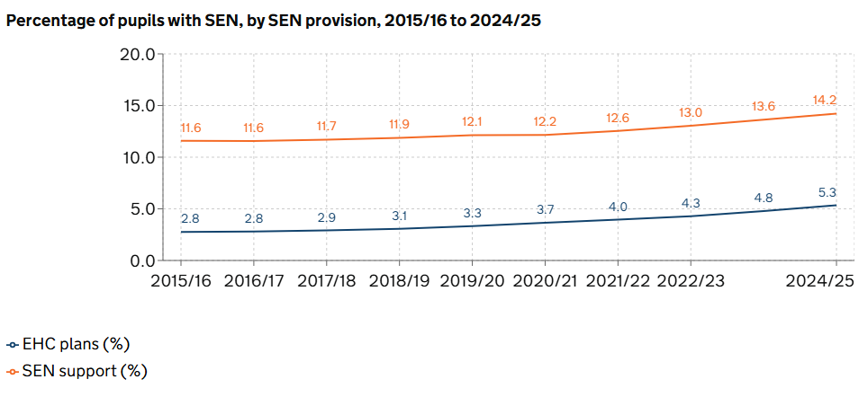

How Redhill Primary Academy Compares to SEND Nationally

SEN Support and EHC Plan Breakdown At Redhill Primary Academy
Taken from Redhill Primary Academy’s overview of needs based on Oct 2025 OFSTED IDSR
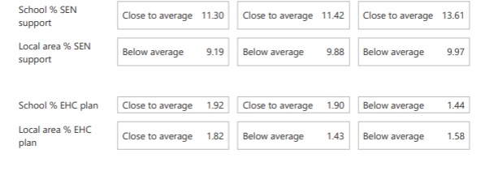

SEN characteristics 2025 Type of resourced provision:

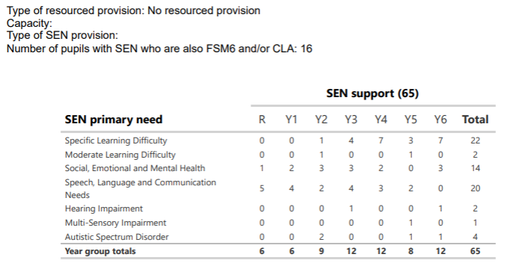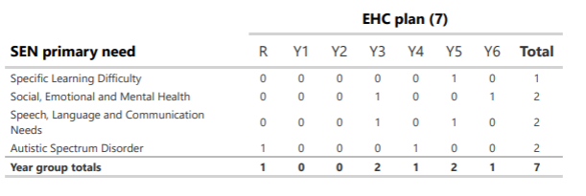

Attendance percentages and persistent absence percentages
